**User testing 1:**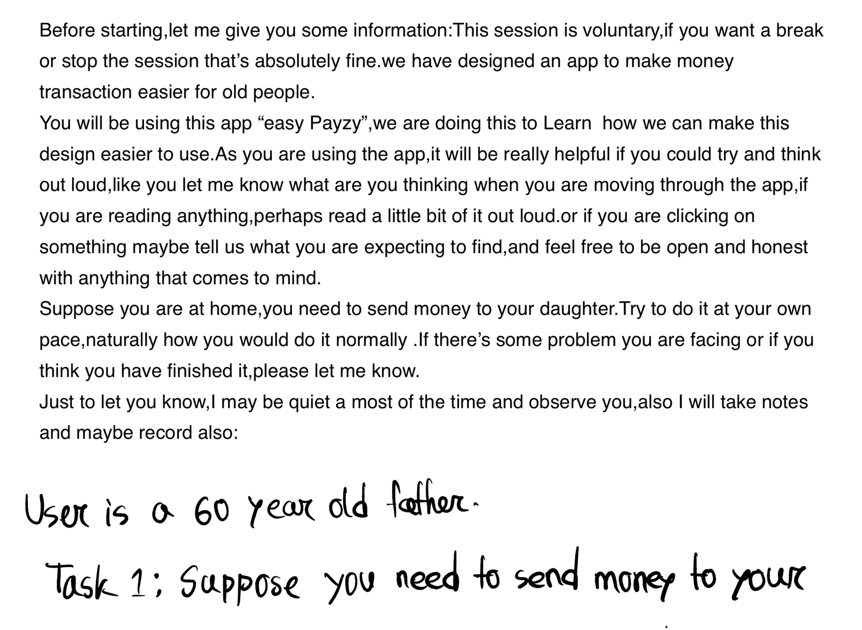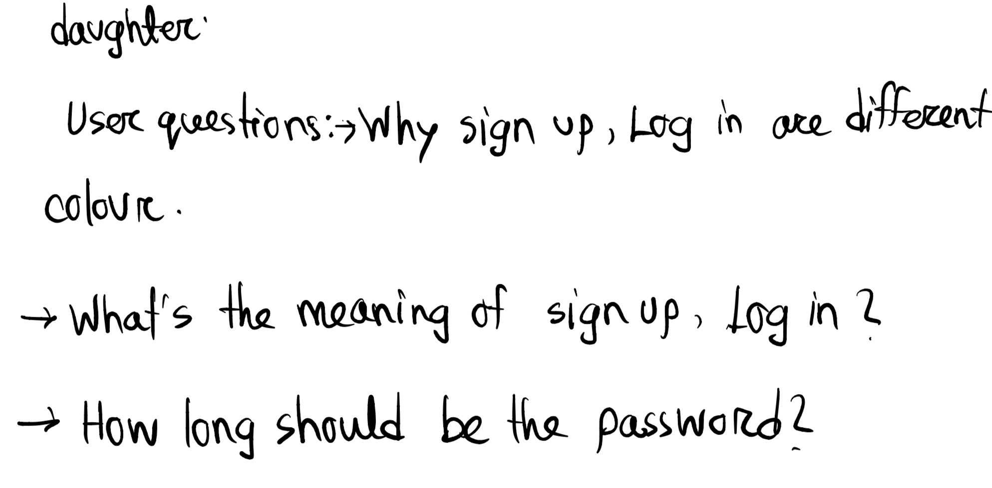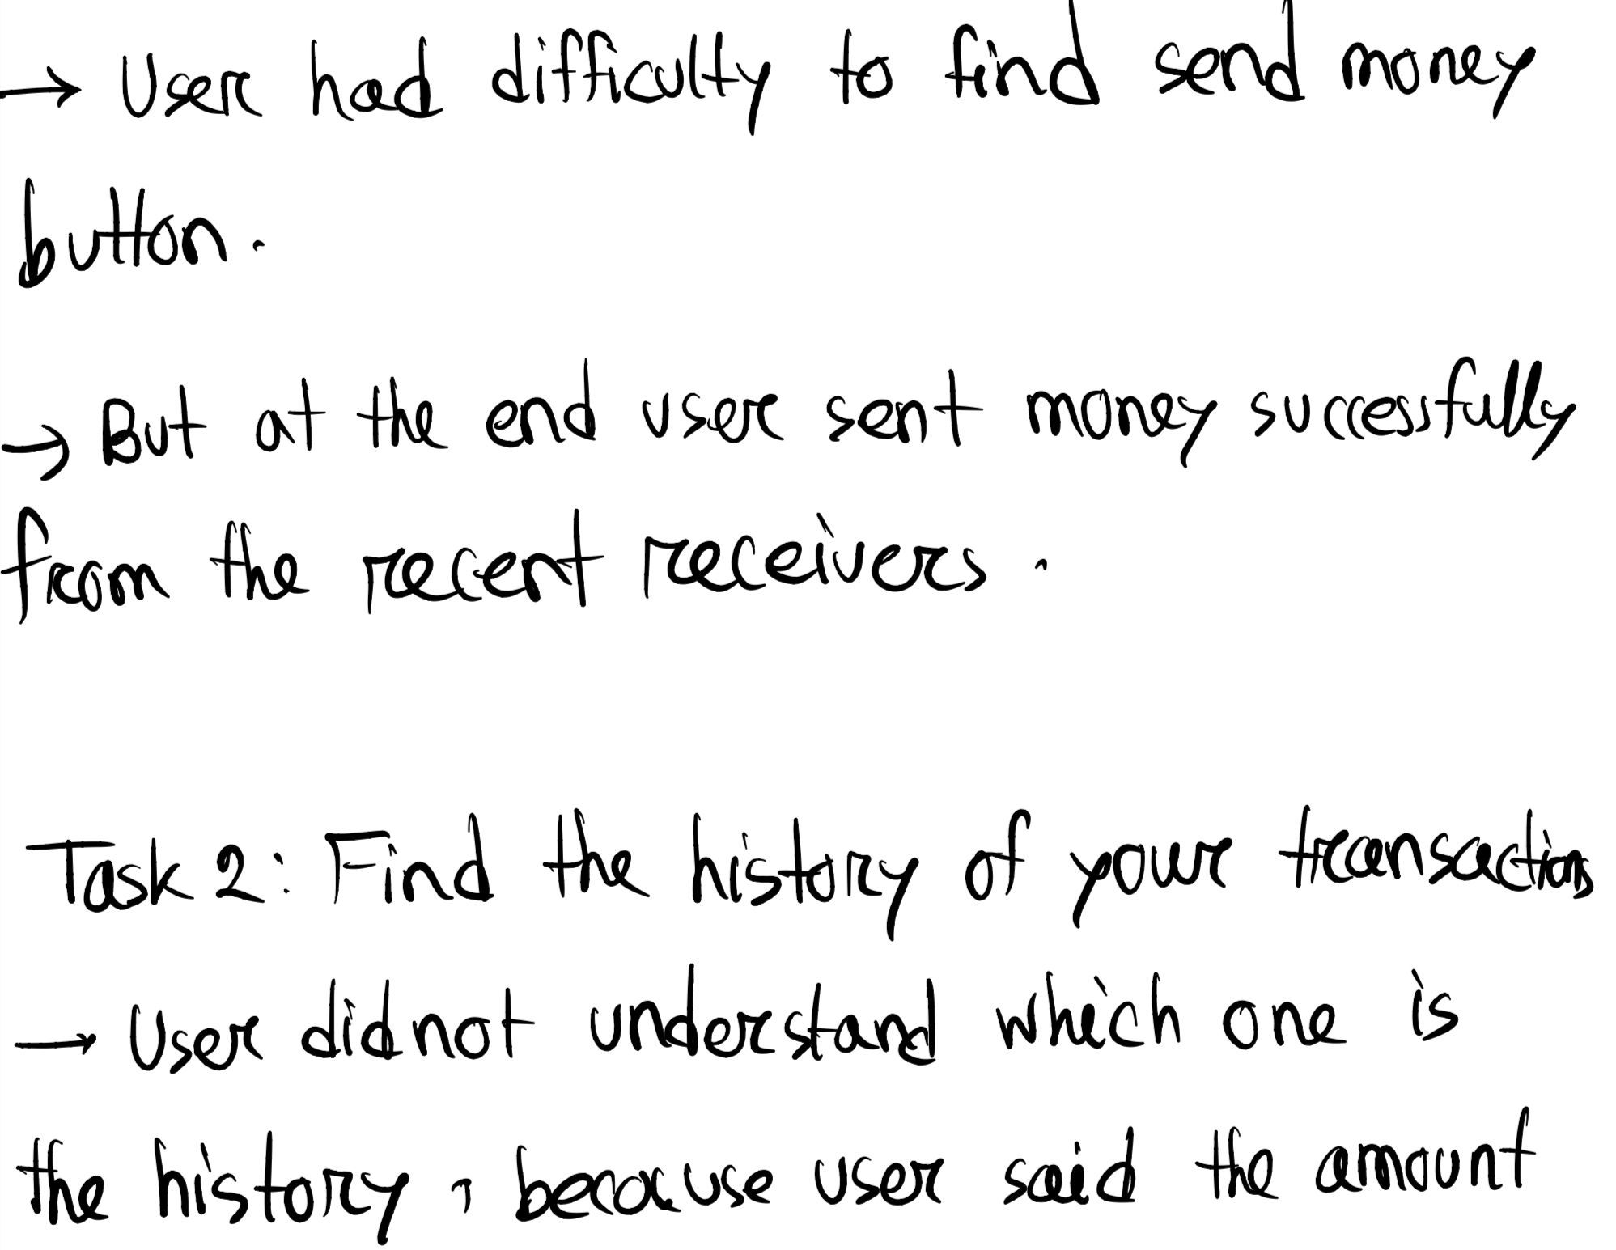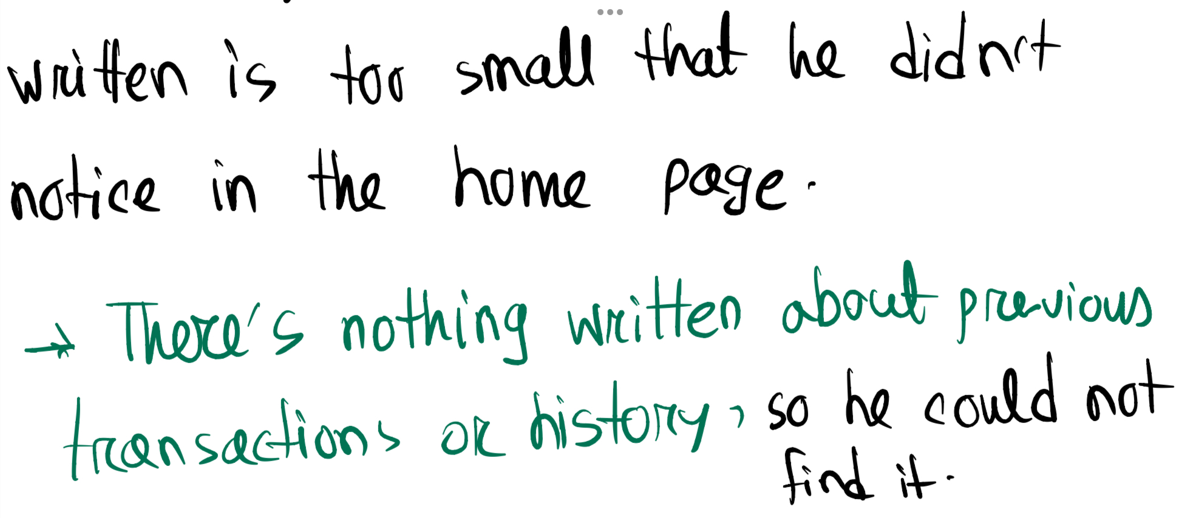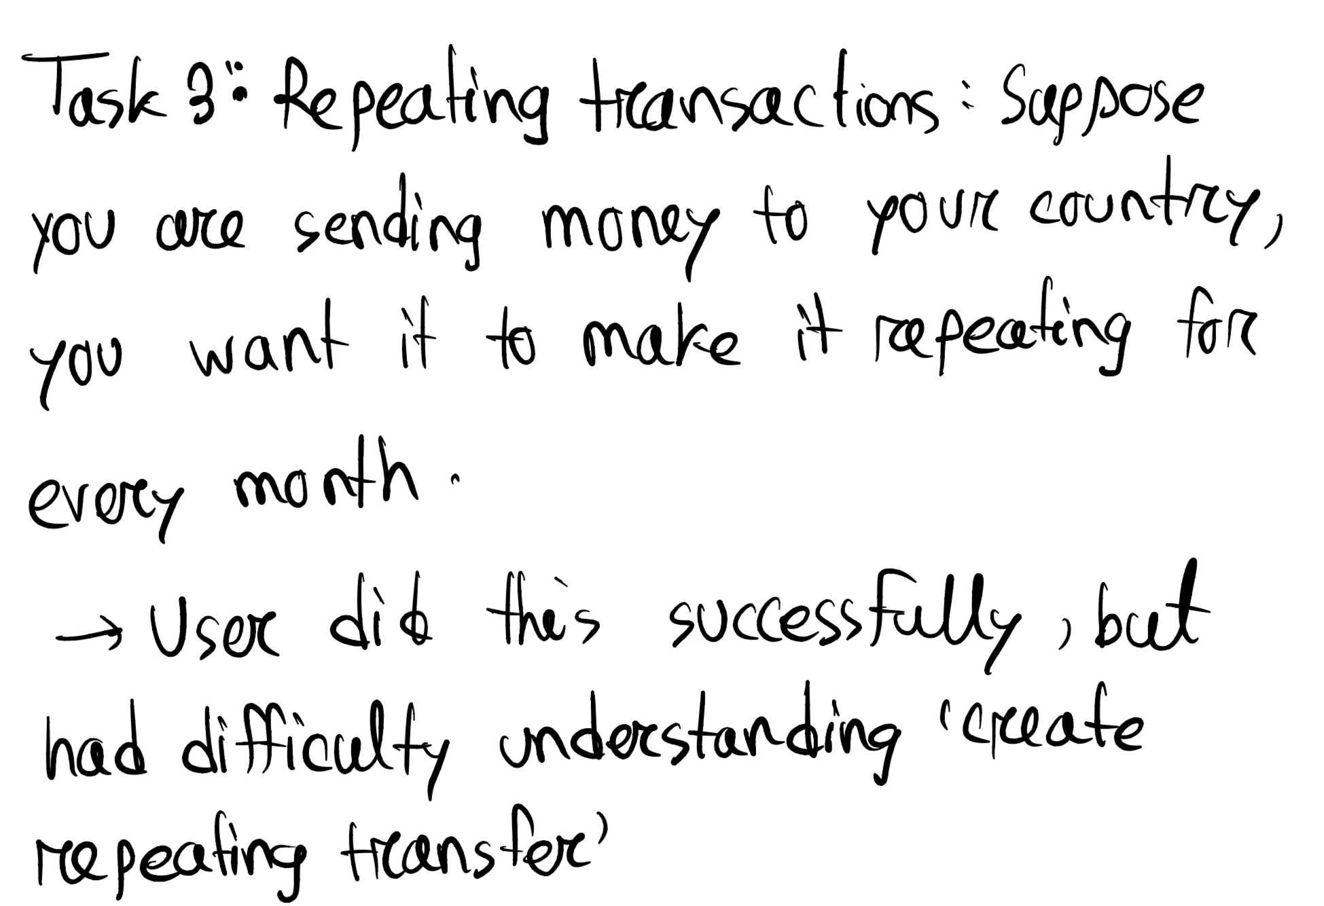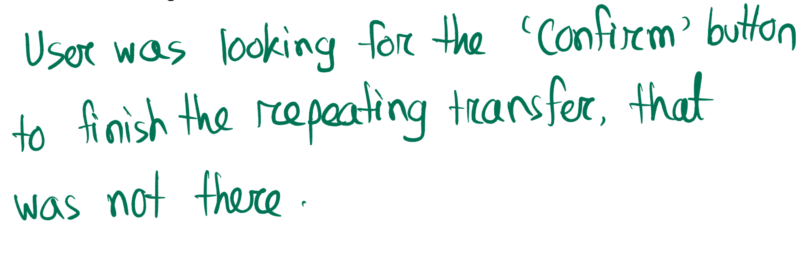

**User testing 2:**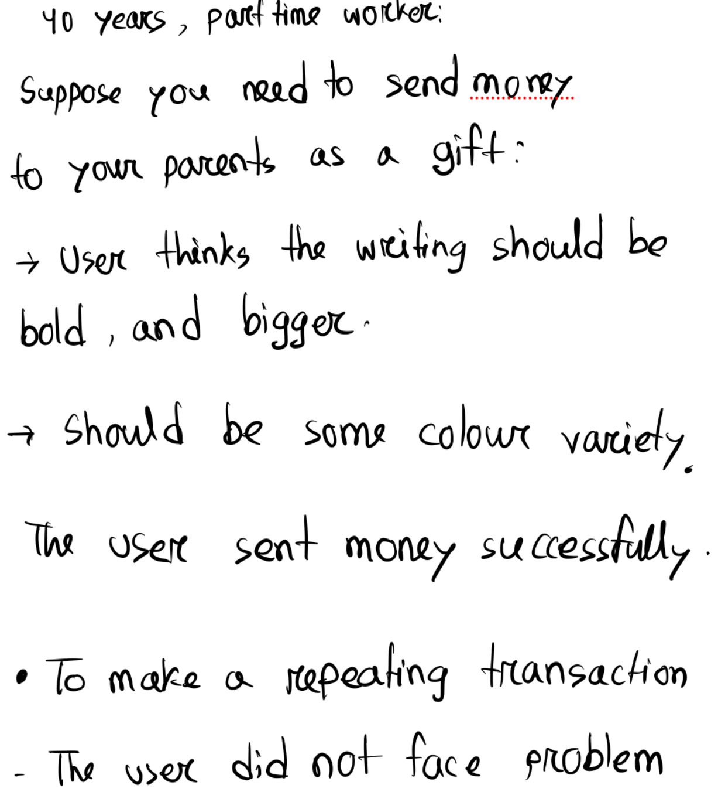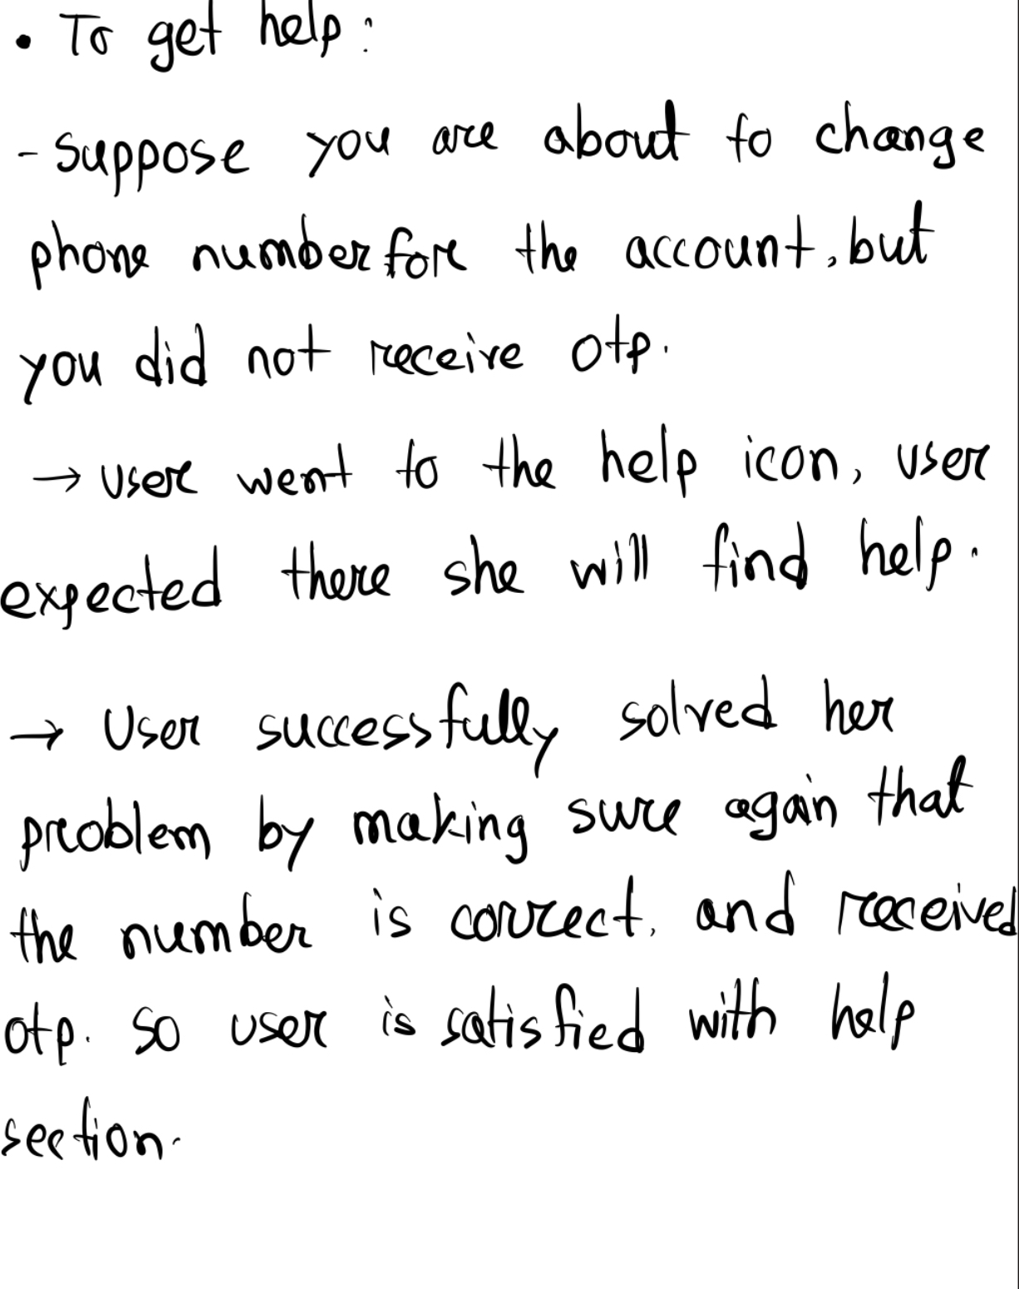

**User testing 3:**

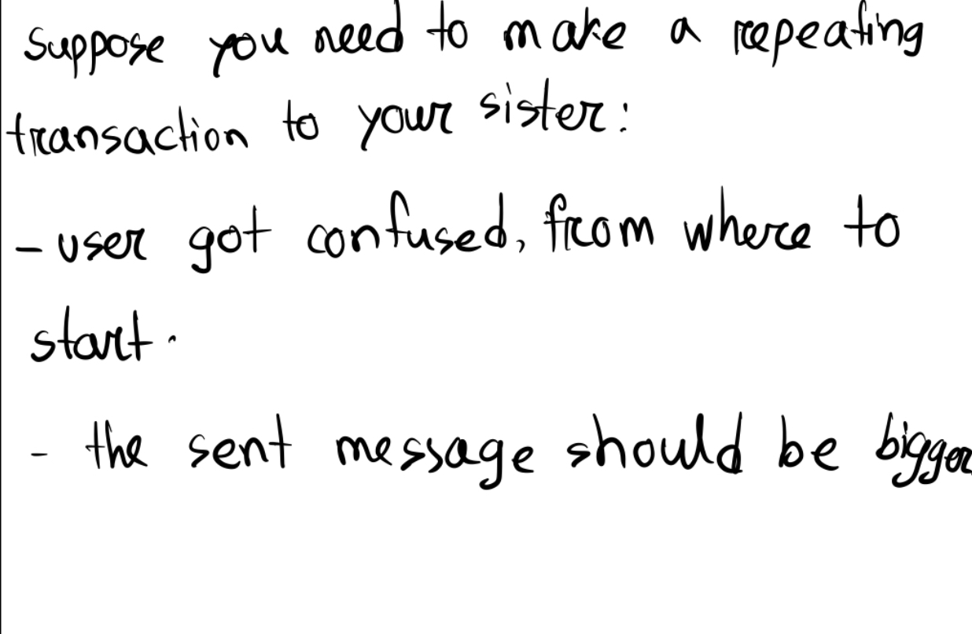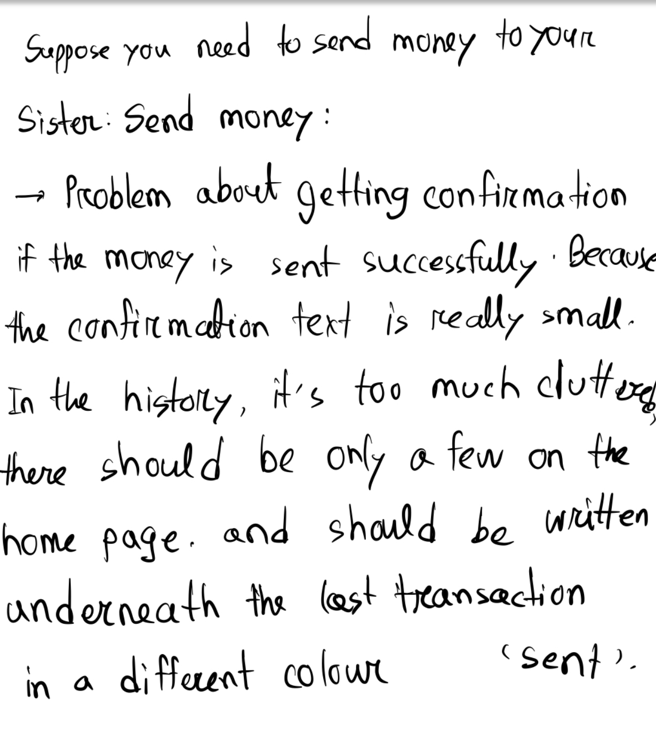

**User testing-4:**

A **56 years** old shop owner

**Task-1:**

Suppose this is your mobile transaction app. Try to send 10€ to any of your family members using this mobile transaction app.

**Task-2:**

Do you have to send money to your family,friends or any of your service providers every month?

-The shop owner replied that he need to transfer money every month to the workers of his shop

OK.**Now assume that you want to set repeating transactions of 700€ for the workers of your shop.Now try to do it using our transaction app.**

**Task-3:**

Suppose you forgot your password now try to recover your password using this transaction app

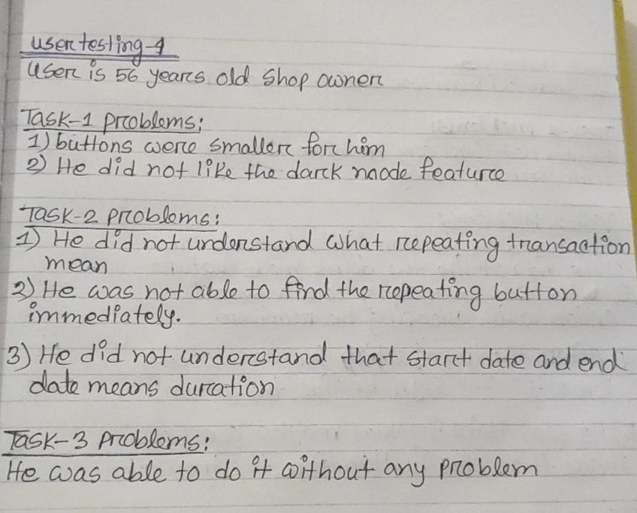

**User Testing-5:**

A **58 year** old man was sitting in the bar

**Task-1:**

Do you send money to someone through the mobile transaction app?

He replied that he sends money to his wife sometimes through the mobile transaction app.

- OK now **Assume this is your mobile transaction app. Now try to send 20€ to your wife through this app.**

**Task-2:**

Do you have any service providers in your house whom you have to give money to every month?

-Yes, I have a caretaker and I have to send her money every month.

OK. That’s great. **Now assume this is your mobile transaction app. Now try to make a repeating transaction of 800€**  **for your caretaker**

**Task-3:**

Suppose you want to change the password of your account now try to do this using this app

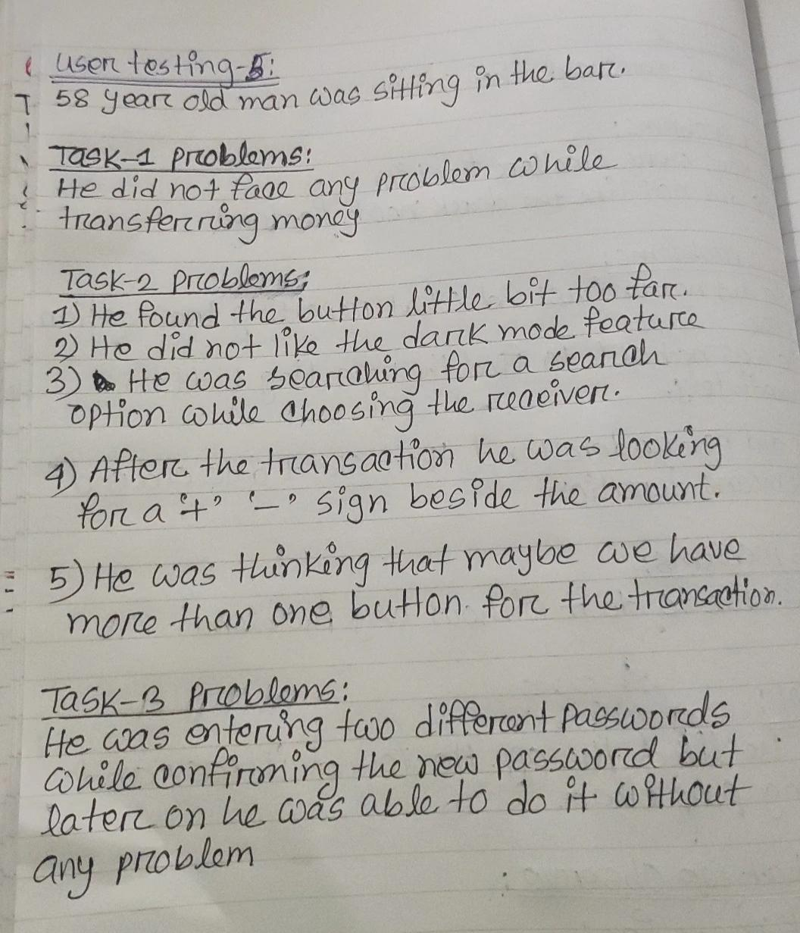

**User Testing-6:**

A **52 years** old doctor

**Task-1:**

Suppose this is your mobile transaction app.Now try to send 50€ to your son

**Task-2:**

Suppose you have to send 100€ to your mother every month now try to do this using this mobile transaction app

**Task-3:**

Suppose you have to edit the recurrence that you have set just because you have inserted the wrong amount. Now try to do it by yourself.

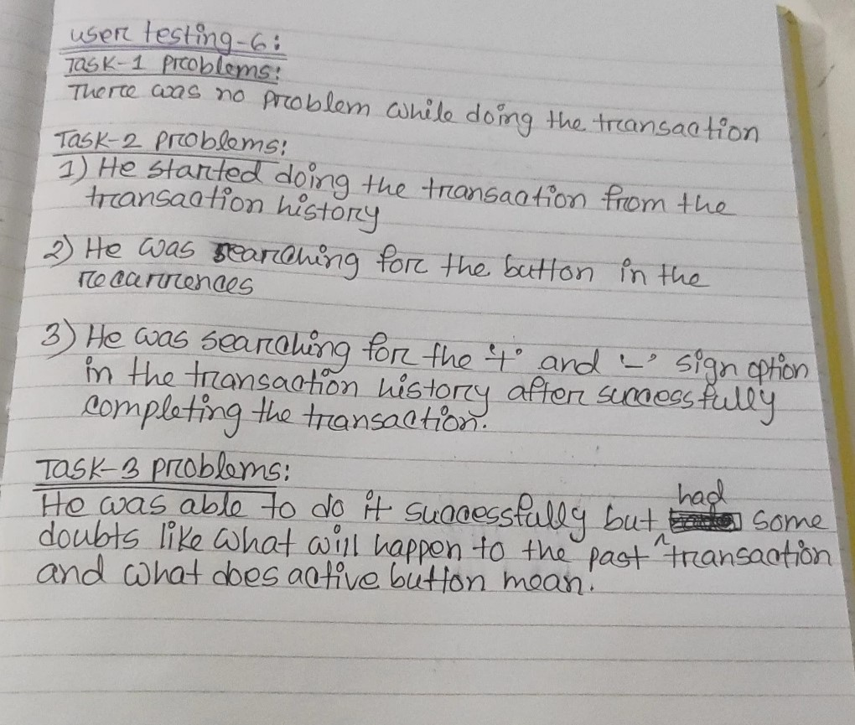

**User testing-7:**

A **60 years** old man was sitting in the park

**Task-1**

Suppose this is your money transaction app now try to send 50€ to your daughter through this app

**Task-2:**

Suppose you want to set a monthly recurring transaction to your maid for 600€ euros now try to do it using this transaction app

**Task-3:**

Suppose you want to change your email password now try to do it using this transaction app

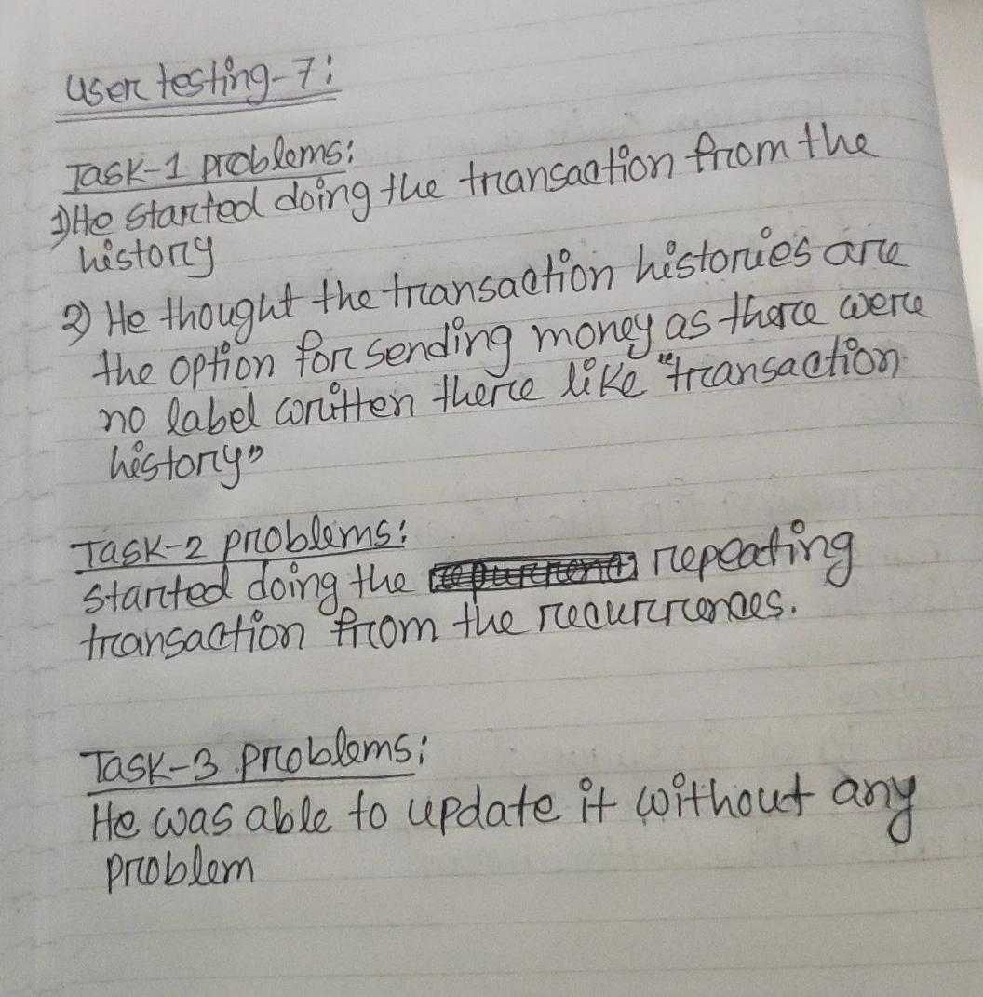

**User testing 8:**

A 42 years old Florist

**Task :**

Suppose you send rent to your landlord every month and now send money to your landlord but make this transaction a repeating or recurring (transaction that is automated every month, week or day you set).

**PROBLEMS**:

1. SEND MONEY BUTTON IS AT THE BOTTOM
2. CAN NOT EDIT THE RECURRENT TRANSACTION FROM THE HISTORY
3. SHOULD HAVE AN OPTION WHERE USER CAN SET A TIME(MEANS AN EXACT TIME WHEN RECEIVER GONNA RECEIVE THE MONEY )
4. USER SAID THE HOME SCREEN LOOKED A BIT CLUTTER AND WOULD BE BETTER IF ALL THE HISTORIES ARE NOT SHOWN ON THE SCREEN  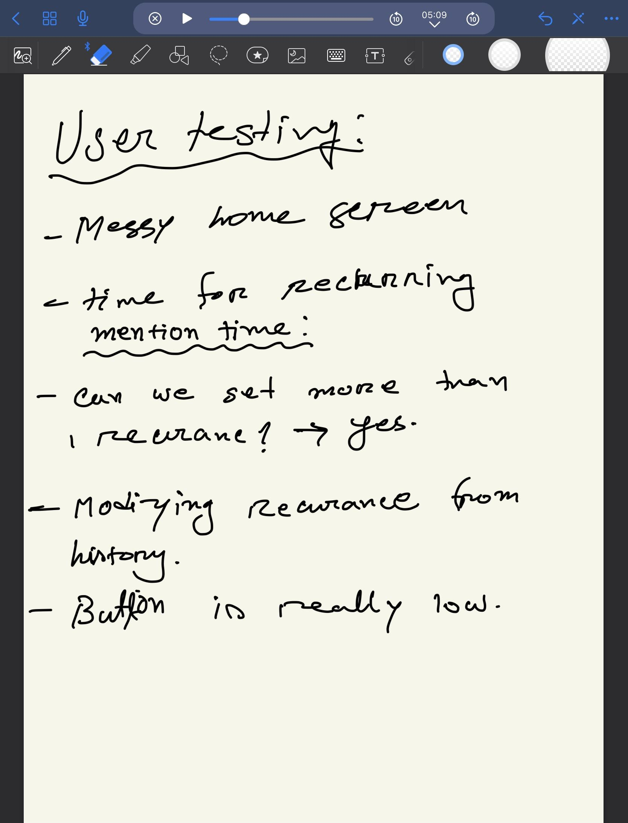

**User testing-9:**

**A 62 years old man sitting in the park**

**TASK:**

SUPPOSE YOU NEED TO PAY OR SEND MONEY TO YOUR WORKER IN EVERY WEEK CAN YOU PLEASE TRY TO MAKE A REPEATING TRANSACTION THROUGH OUR APP

**PROBLEMS**

1. Users find it a bit difficult to set the repeating transaction especially did not get the start date and end date.

**2.**Icon should be more specific about my profile.

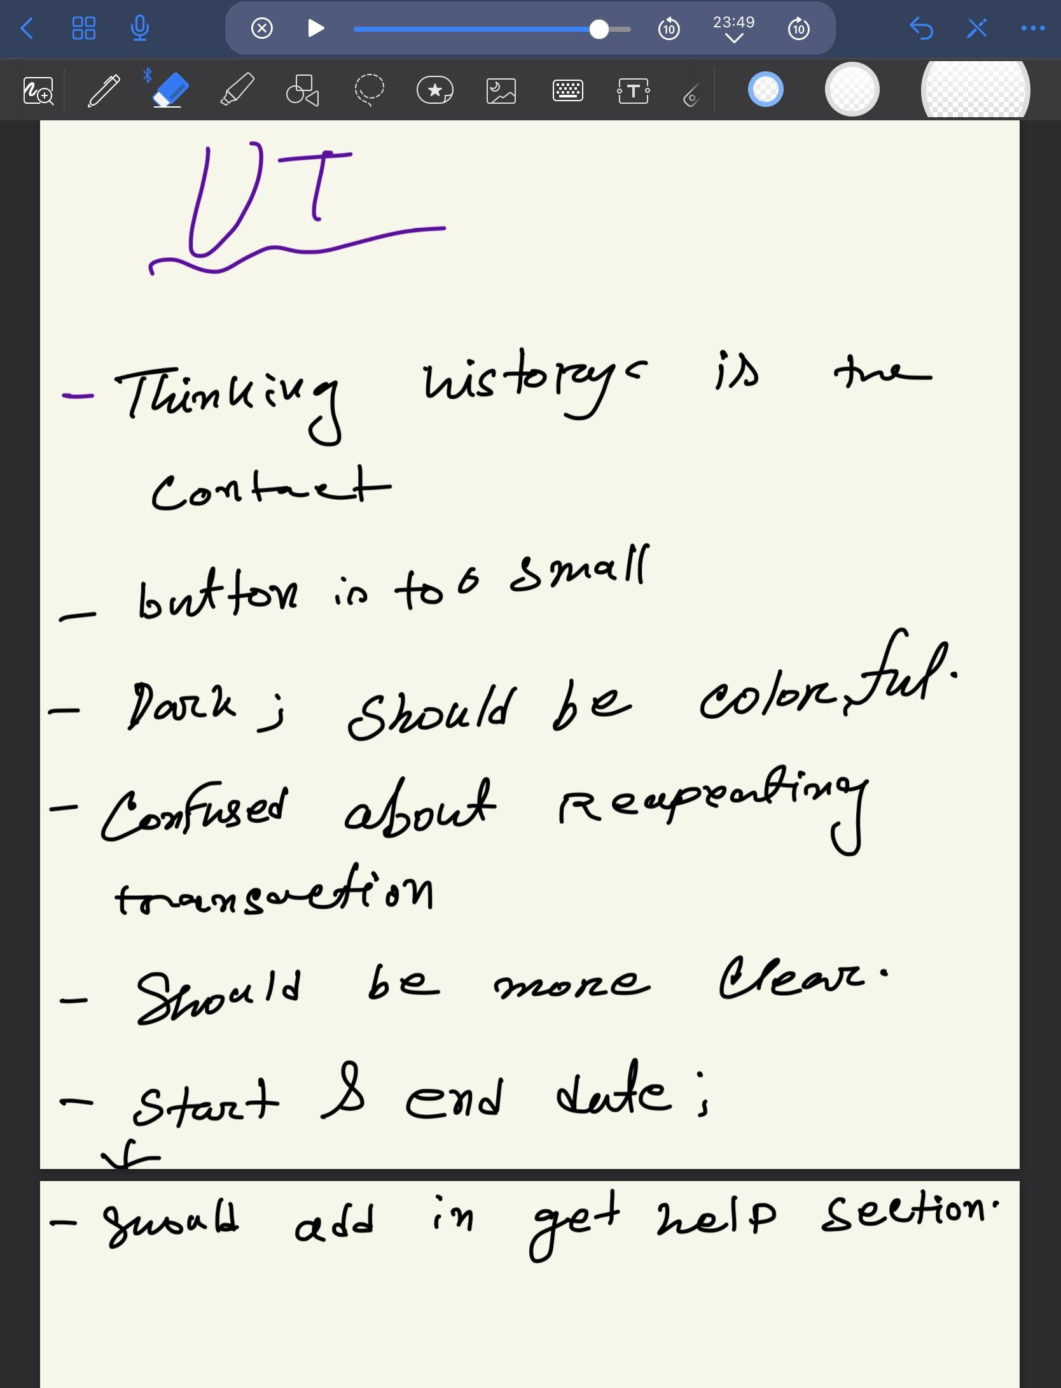

**User Testing 10:**

**46 years old shop owner**

**Task 1:** Suppose this is your money transaction app now try to send 15€ to your friend through this app

**FEEDBACK:** THE USER DID NOT FIND IT DIFFICULT TO SEND MONEY BUT HAD SOME OTHER PROBLEMS MENTIONED BELOW

**PROBLEMS:**

**1.** Preferred normal interface rather than the dark mode.

2. Suggested to add a “+” button for received money and a “-” button for money which has been sent

3.Wanted some colored buttons that would make those buttons more visible.

**Task 2;**

Asked user to make a repeating transaction

**PROBLEMS:**

1. User was having difficulty to find or understand where she should make the repeating transaction. Though ultimately she was able to do it
2. Had the issue with the start and end date.

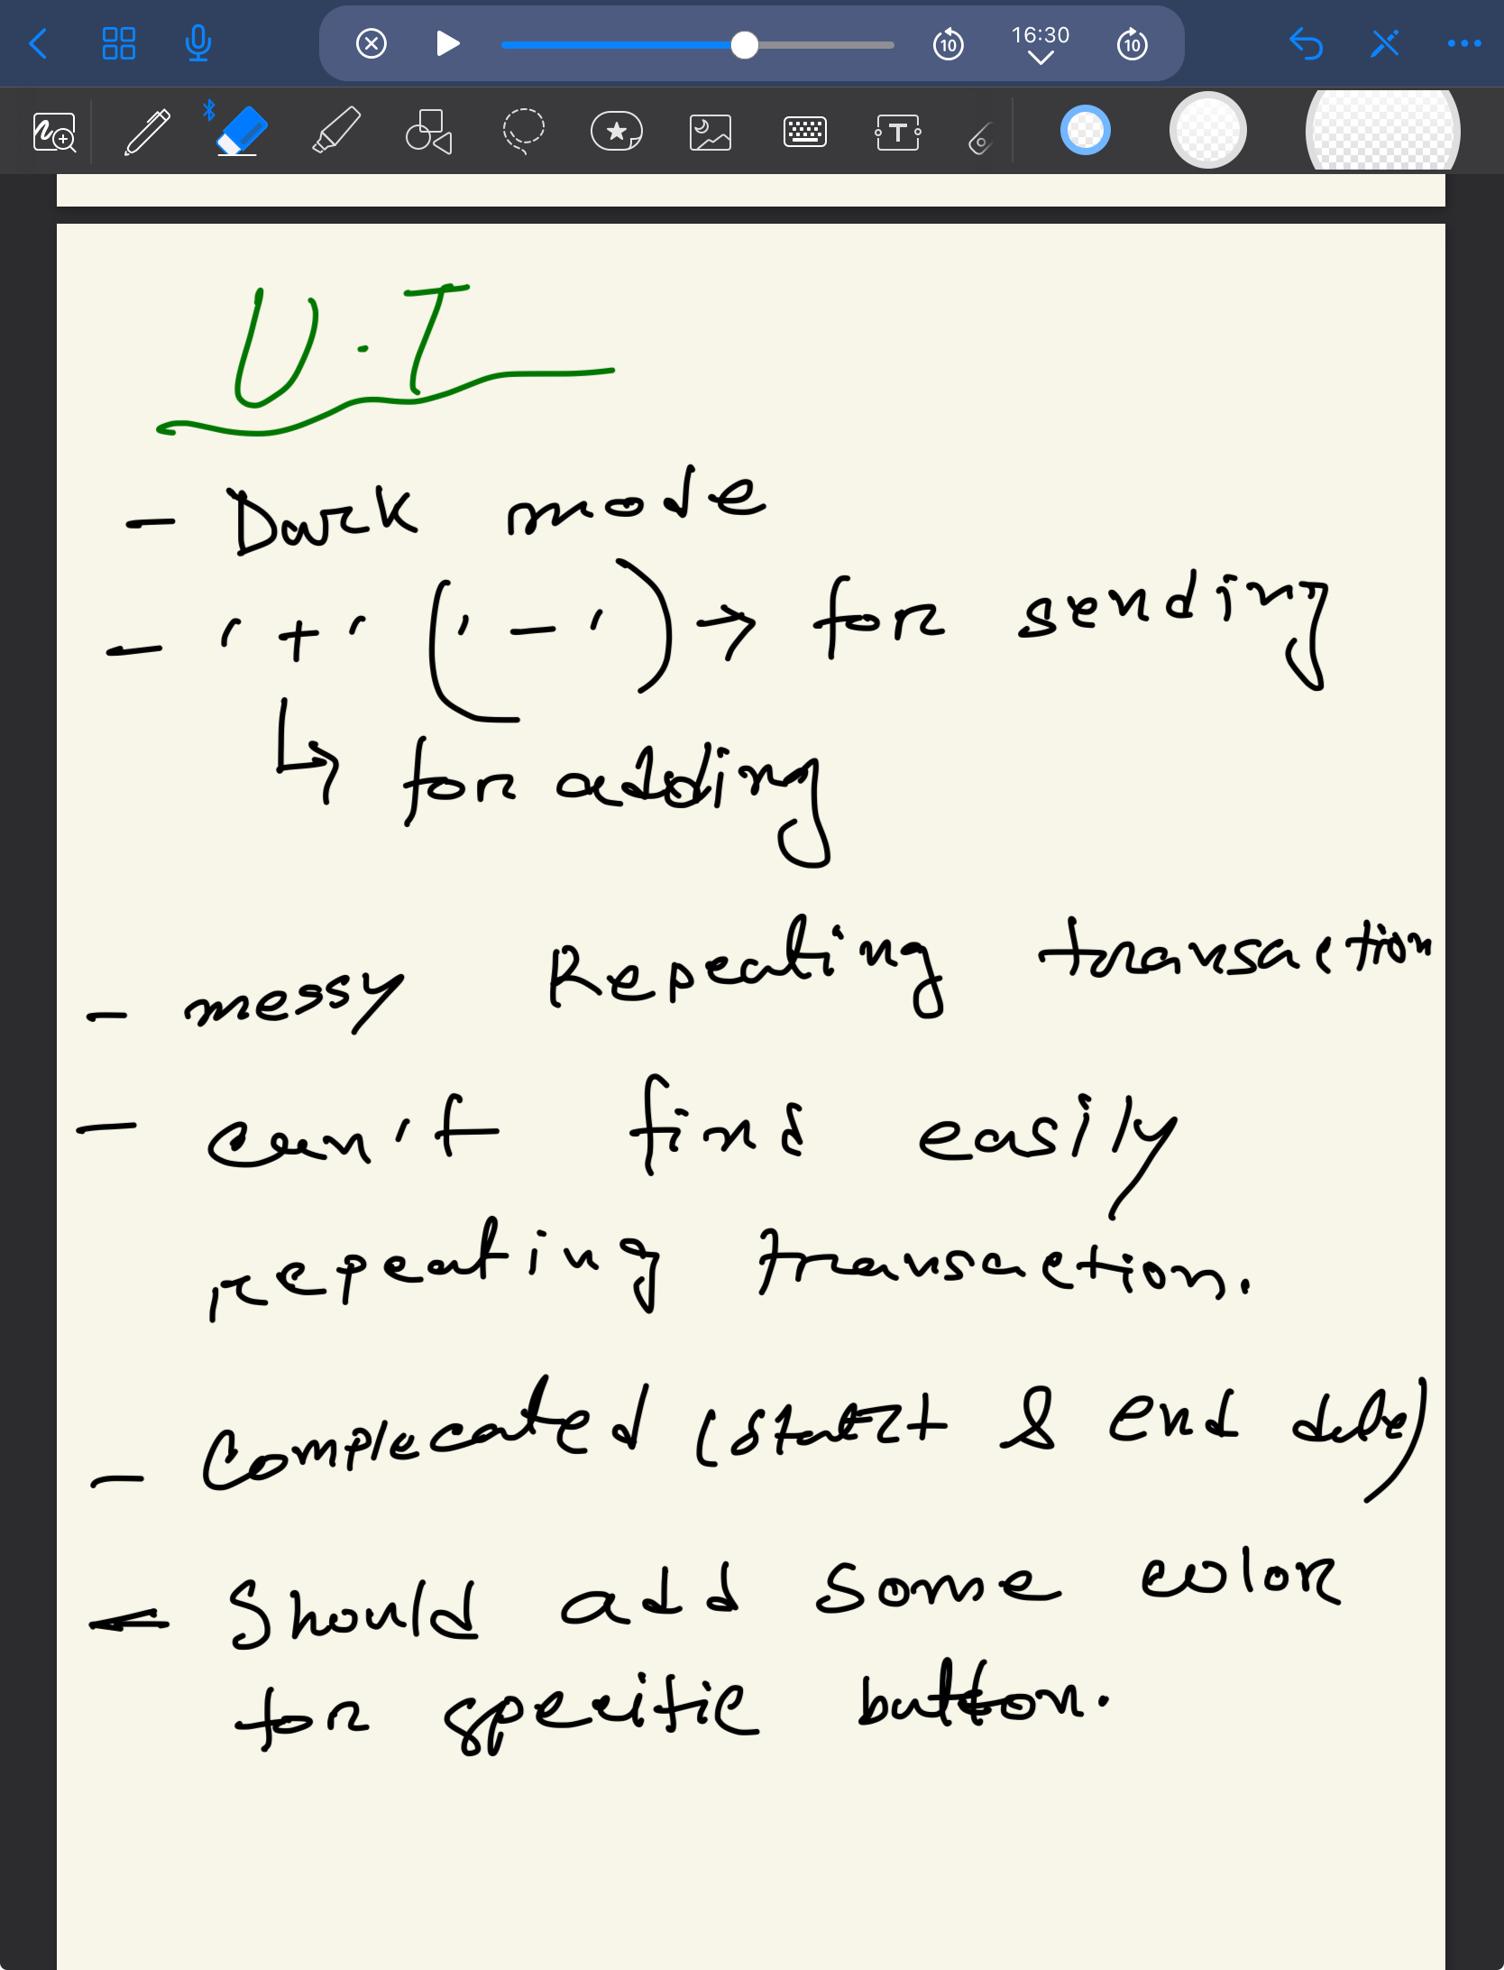

**User testing 11:Using CHATGPT:**

